10 Basic programs

**Name: K. Manoj Kumar Reddy**

**Reg:192425266**

1. **Write a C program to add two numbers entered by the user.**

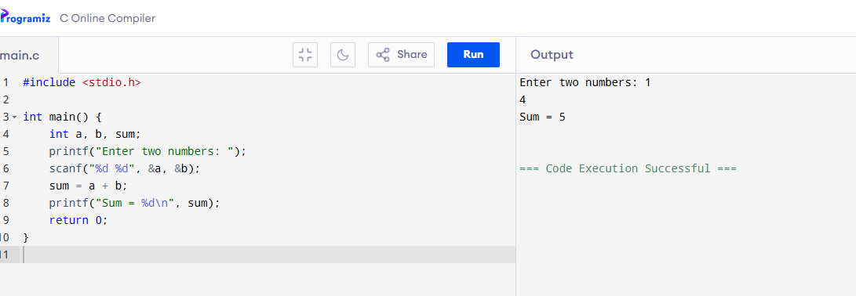

**Result**: Calculates and displays the sum of two numbers**.**

**2.Write a program to check if a number is even or odd.**

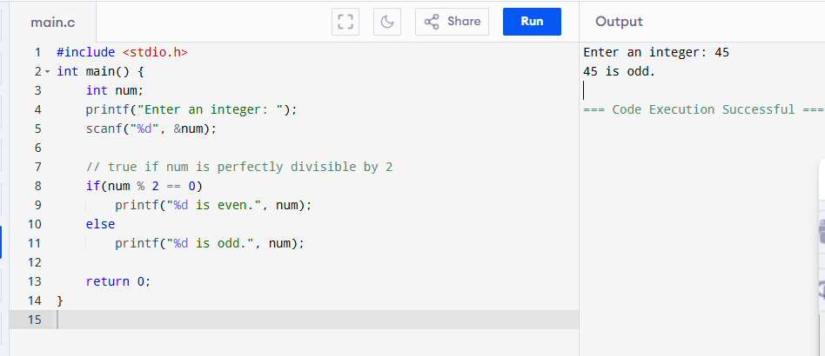

**Result**:Checks divisibility by 2 to decide even or odd.  
Useful to understand conditionals.

**3.Write a program to find the factorial of a number.**

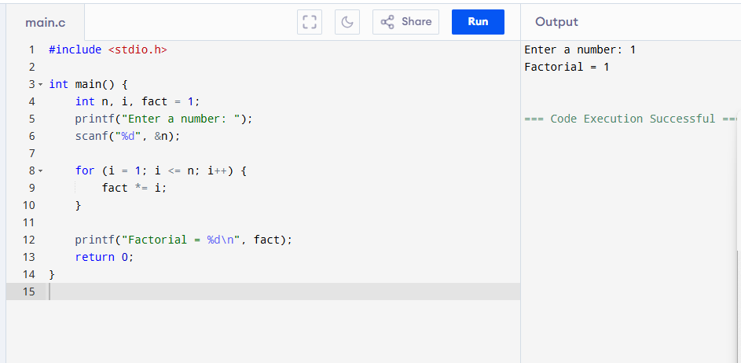

**Result**:  
Multiplies numbers from 1 to n.  
Demonstrates loops and multiplication logic.

1. **Write a program to find the largest of two numbers.**

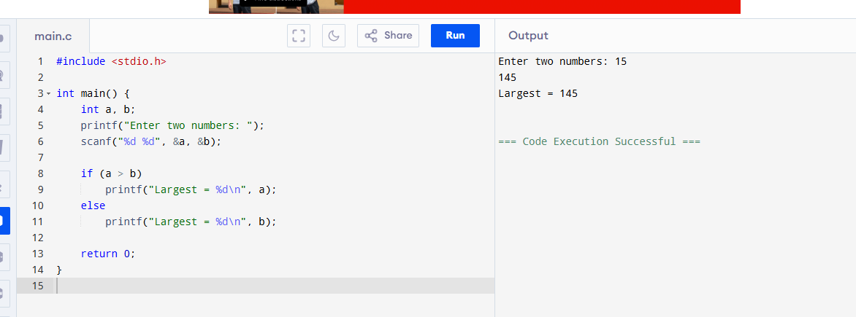

**Result**:  
Compares two numbers and prints the larger one.  
Introduces comparison using if-else.

**5.Write a program to print multiplication table of a number.**

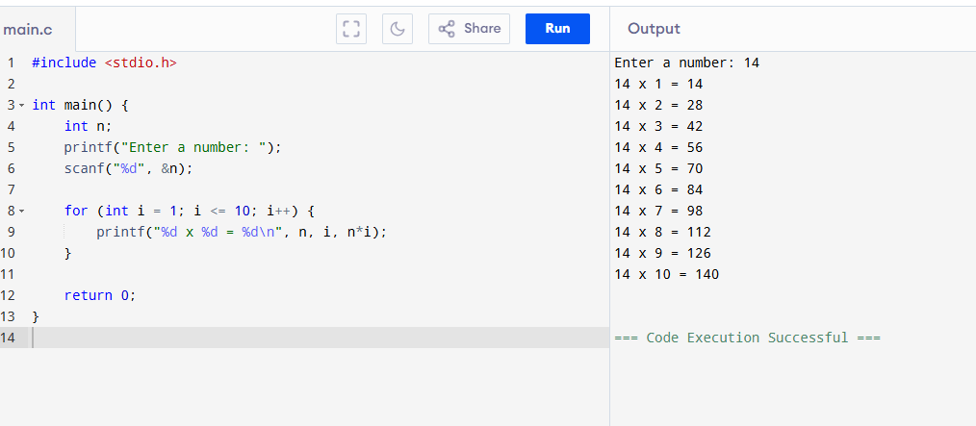

**Result**:  
Prints the multiplication table of a number.  
Good practice for for loops.

**6.Write a program to check if a number is prime.**

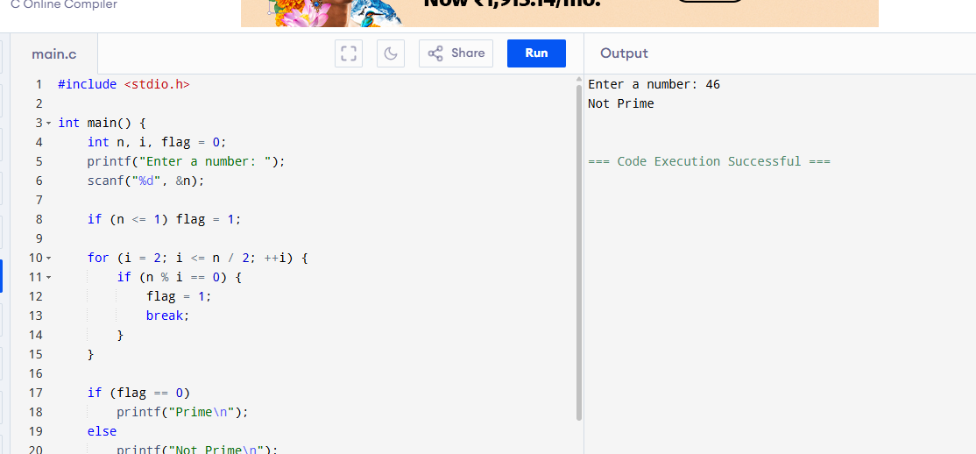

**Result**:  
Checks if a number has factors other than 1 and itself.  
Helps understand logical checks and loops.

**7.Write a program to reverse a number.**

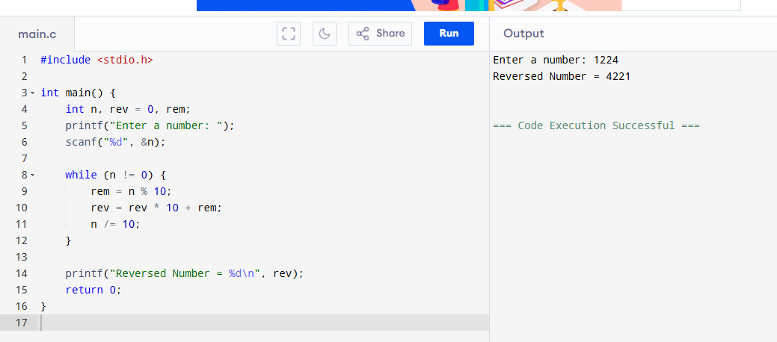

**Result**:  
Extracts digits and rebuilds the number in reverse.  
Teaches while loop and arithmetic.

**8.Write a program to find the sum of digits of a number.**

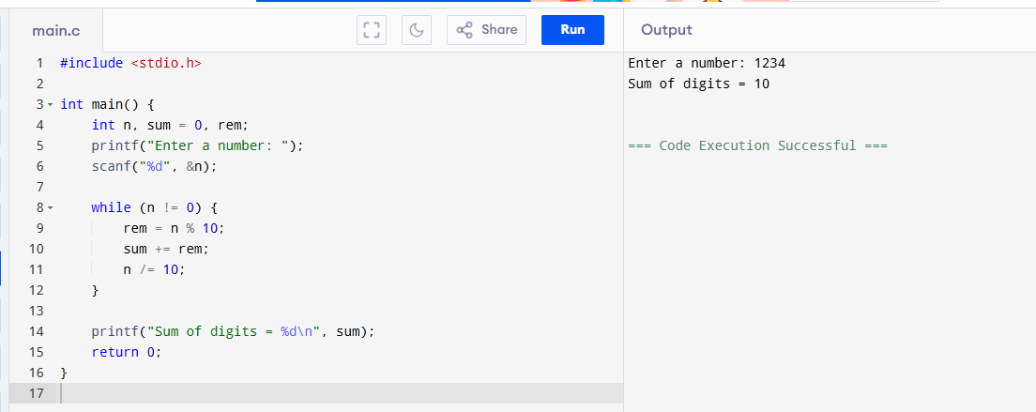

**Result**:  
Swaps two values using a temporary variable.  
Covers basics of variable manipulation.

**9.Write a program to swap two numbers using a temporary variable.**

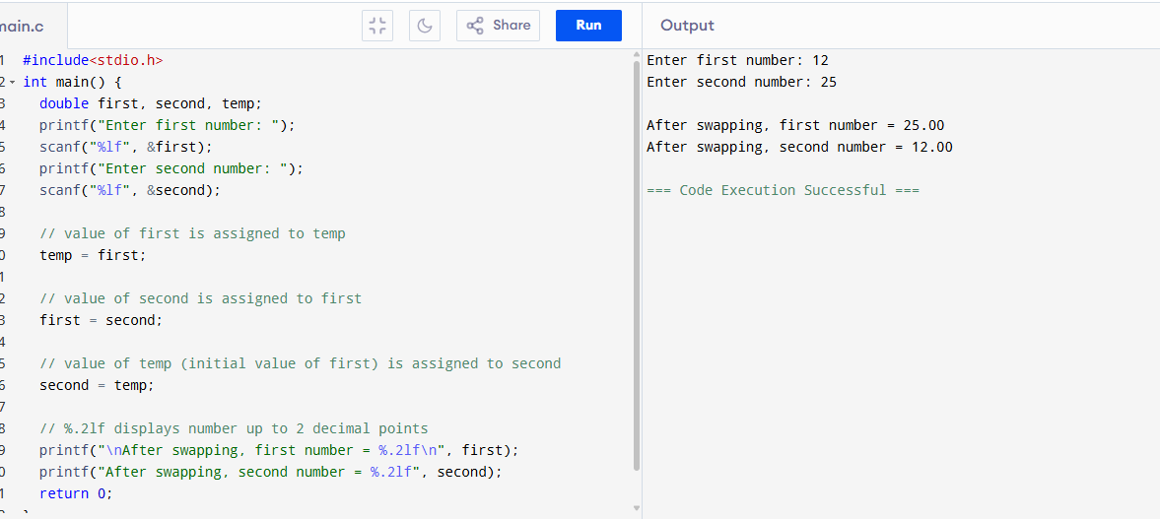

**Result**:  
Swaps two values using a temporary variable.  
Covers basics of variable manipulation.

1. **C Program to Check if a Number is Positive, Negative, or Zero**

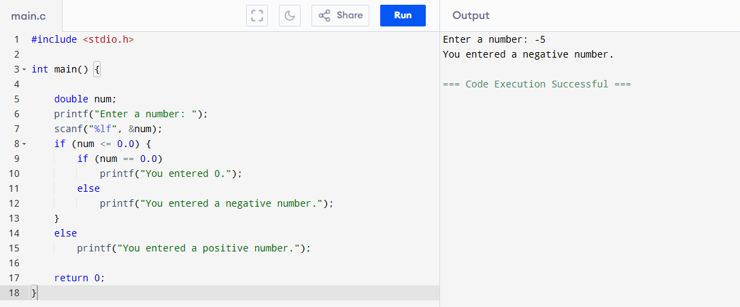

**Result:**This program takes a number as input and checks if it is positive, negative, or zero using if-else conditions.  
It helps beginners understand decision-making in C.